DSS in Pega

It is an instance of the Data-Admin-System-Settings

It is a way to define different system settings in your application.

We can create from create>sysadmin>DSS

Under system pages under pxProcess we can see under pzProductionLevel

We have standard functions called as getDataSystemSettings Data Transform

getDataSyatemSettings and getDataSystemSettings are both and if we need to use these we need to give the ruleset name and the system setting name and we would be getting value from system settings and if we are using get rulesystemsettings it will give us the production level for the result.

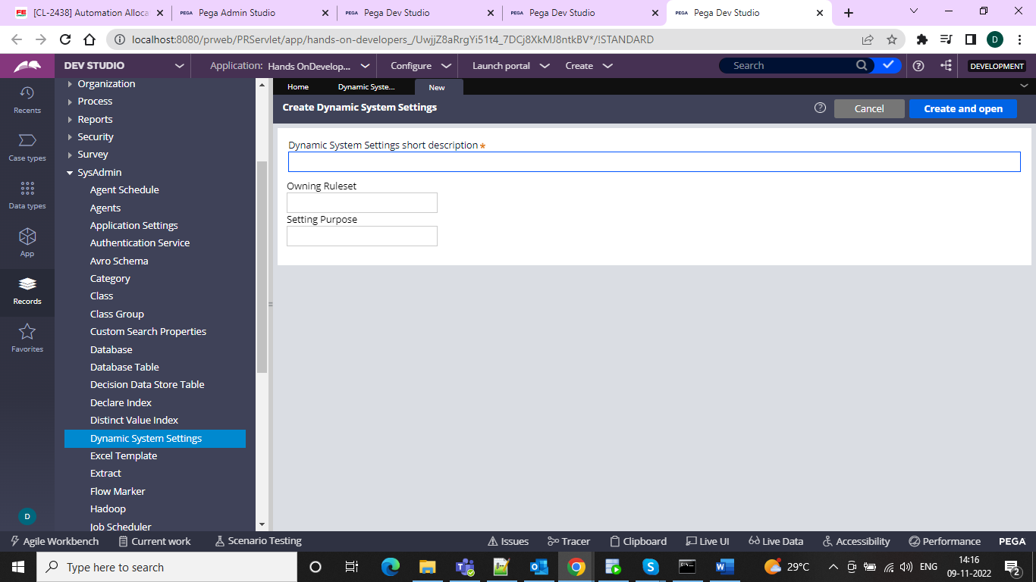

And then in the owning ruleset can give In which ruleset we want to create and for the setting purpose we can give the name as the DSS name which we want to have and inside the value we can give what value we have as the name

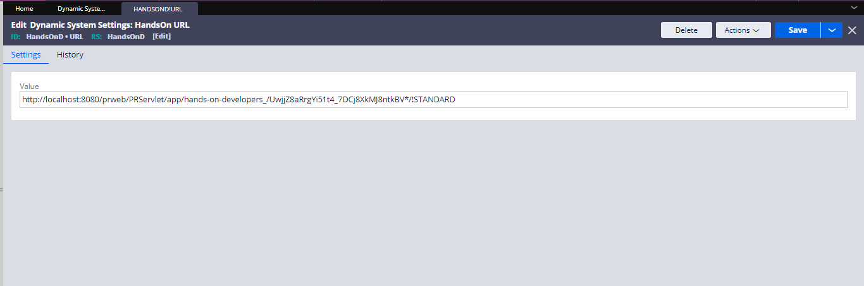

And now we can use this in activities data transforms etc….

And for suppose if I am using DT and mapping to a property and then refer in one section and call this on ether and we can see it anywhere.   
  
So created one case type and in that using section and created one property and then refer it in section and then use pySetFieldDefaults for setting it in the usge.

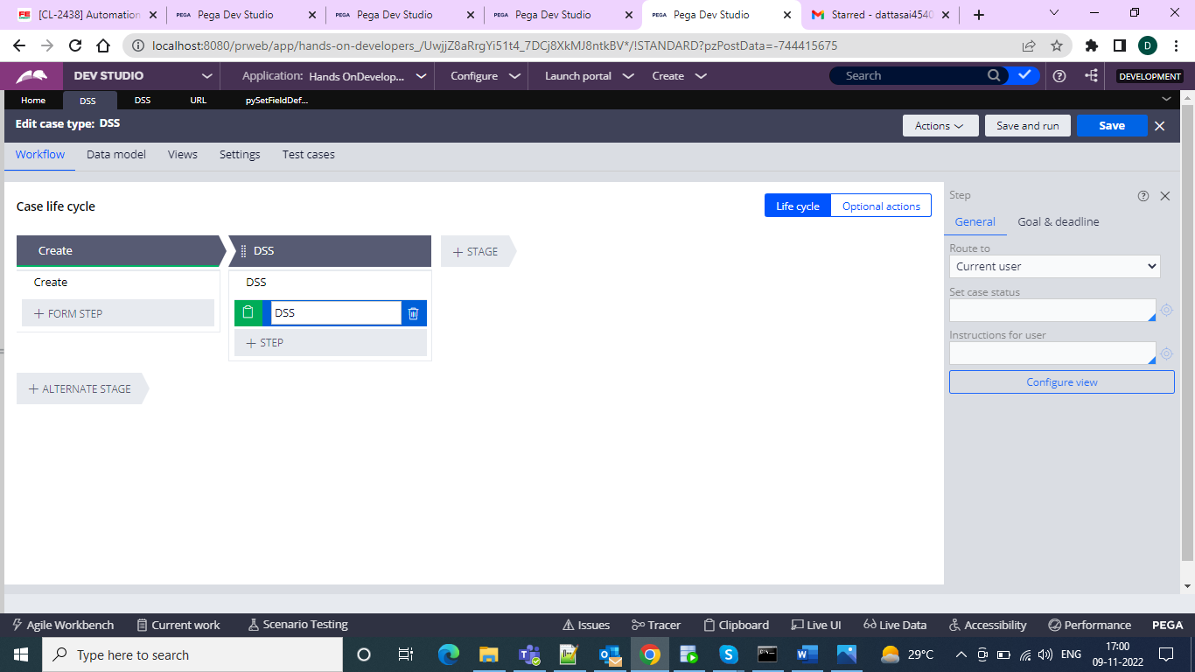

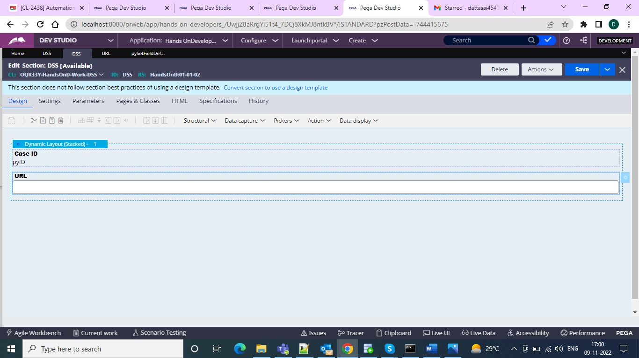

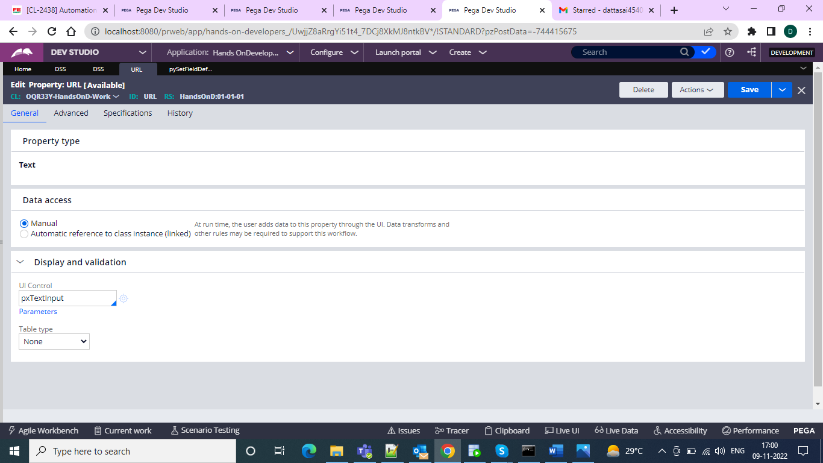

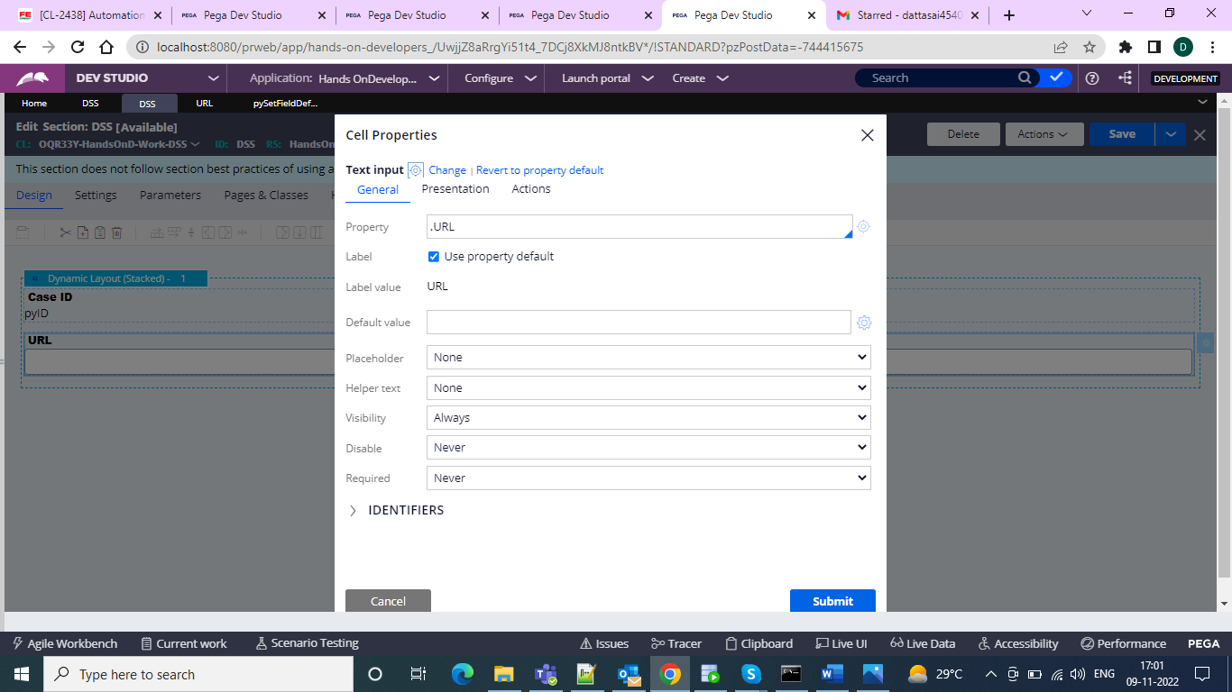

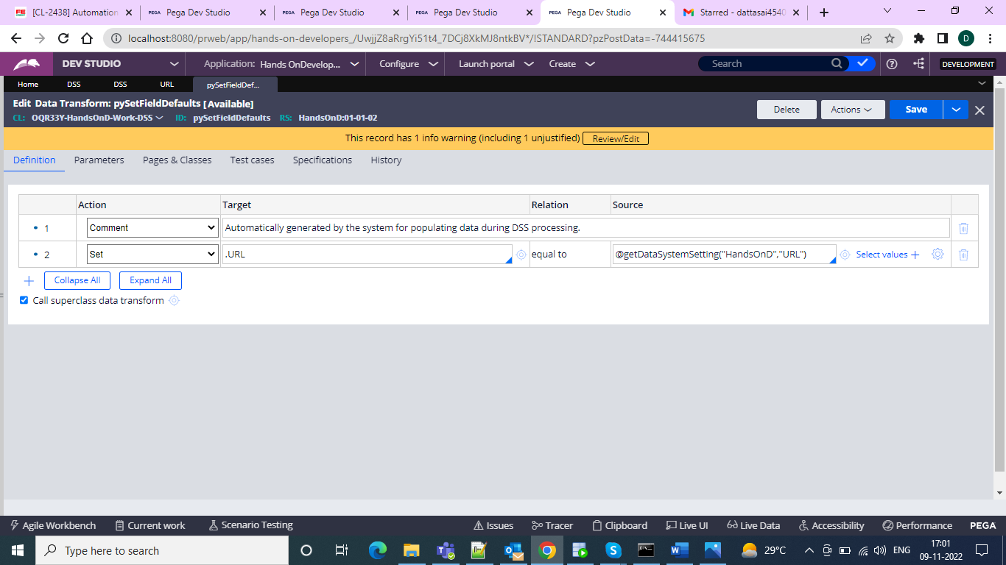

And boom it is setting the DSS

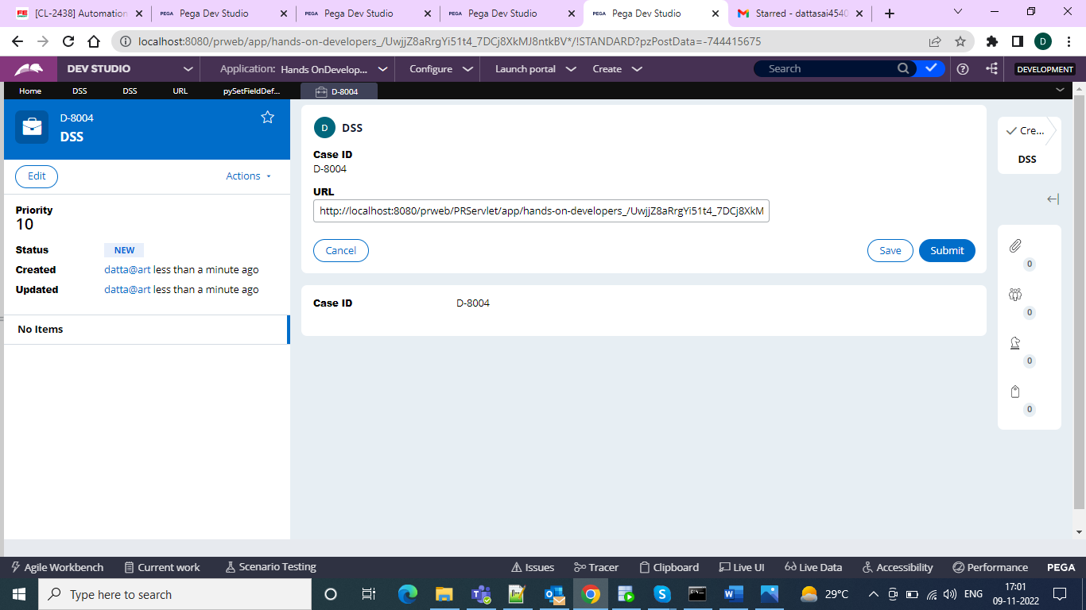

And when comes to ruleSystemSettings

We can create application settings and refer it in the pySetFieldDefaults

We create application settings from the SysAdmin > ApplicaionSettings

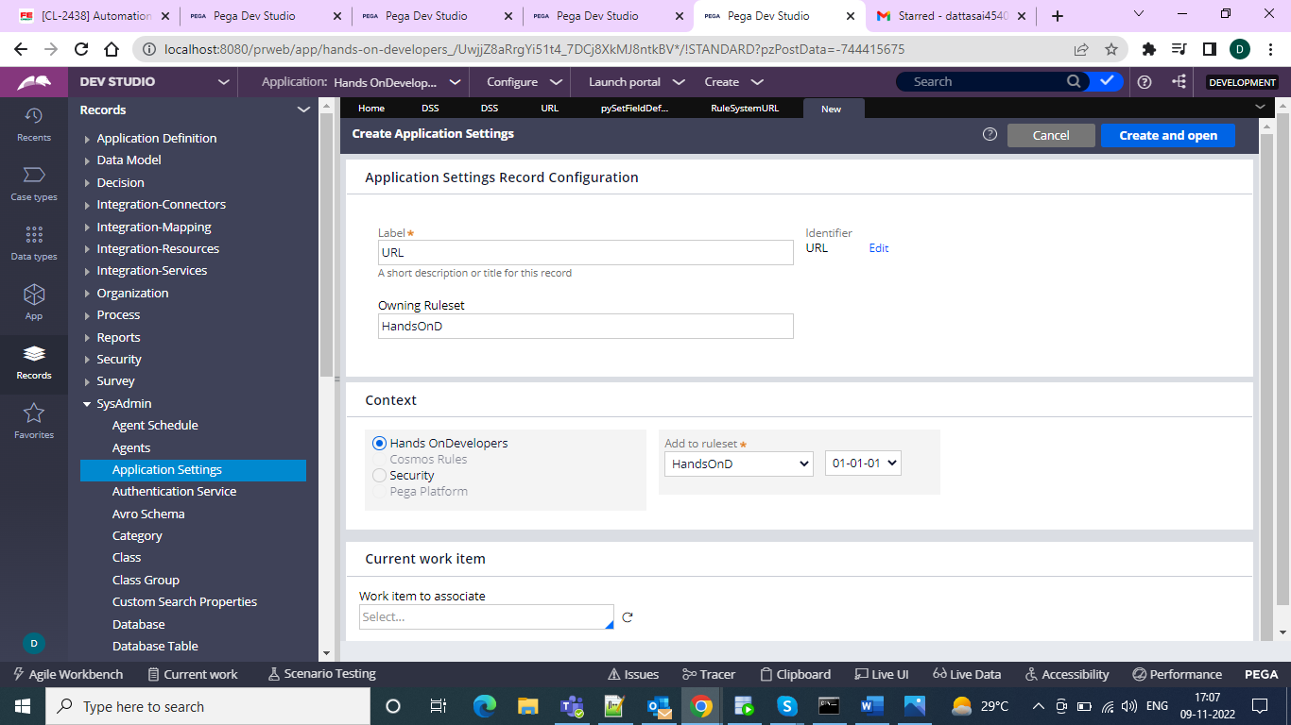

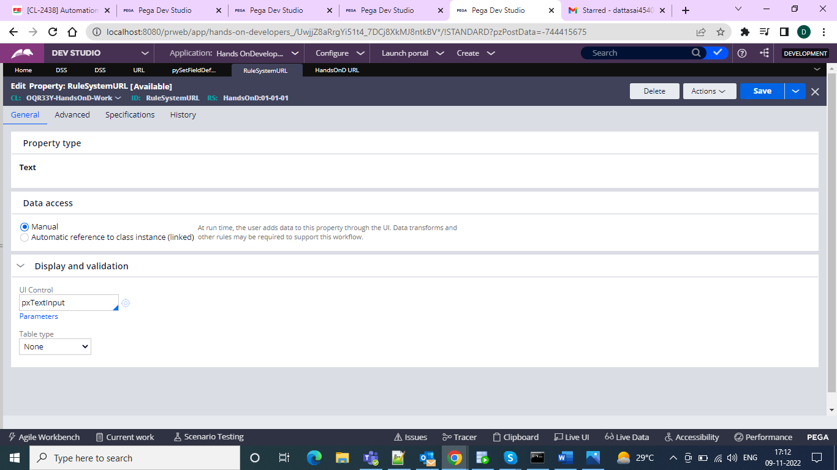

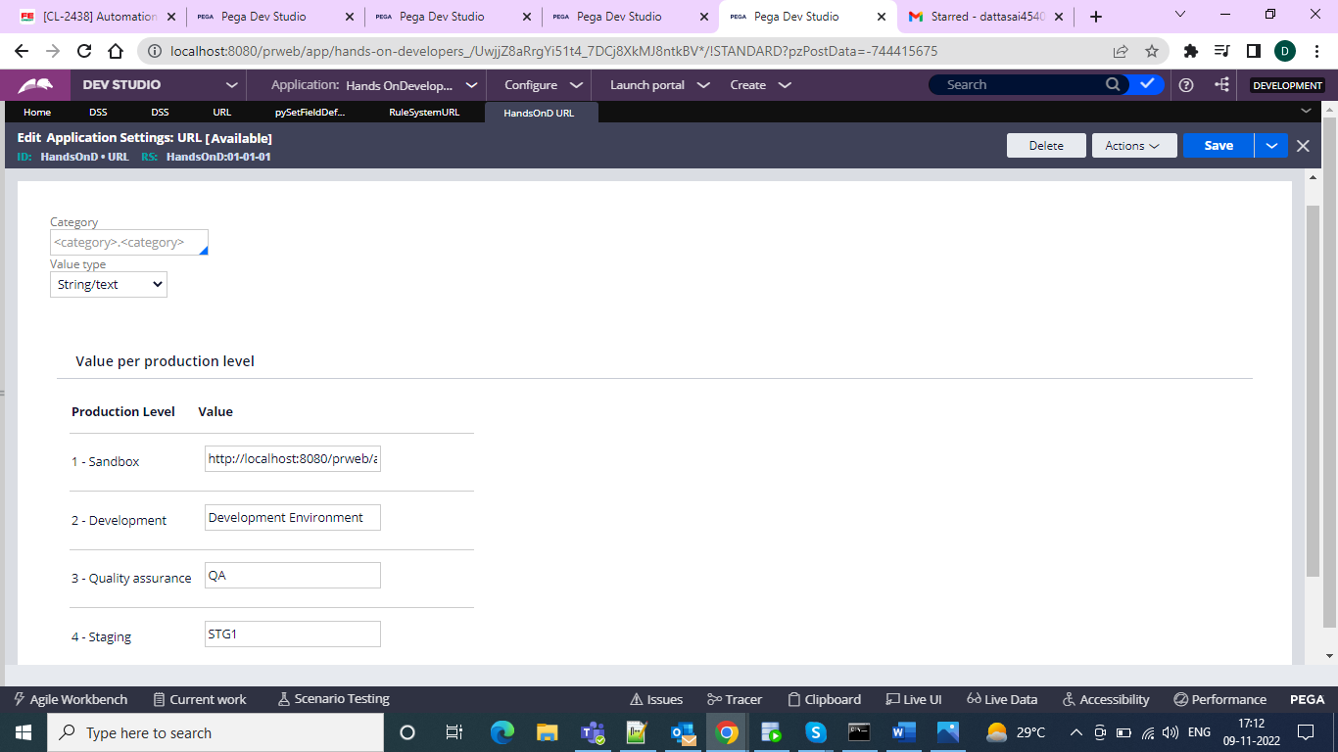

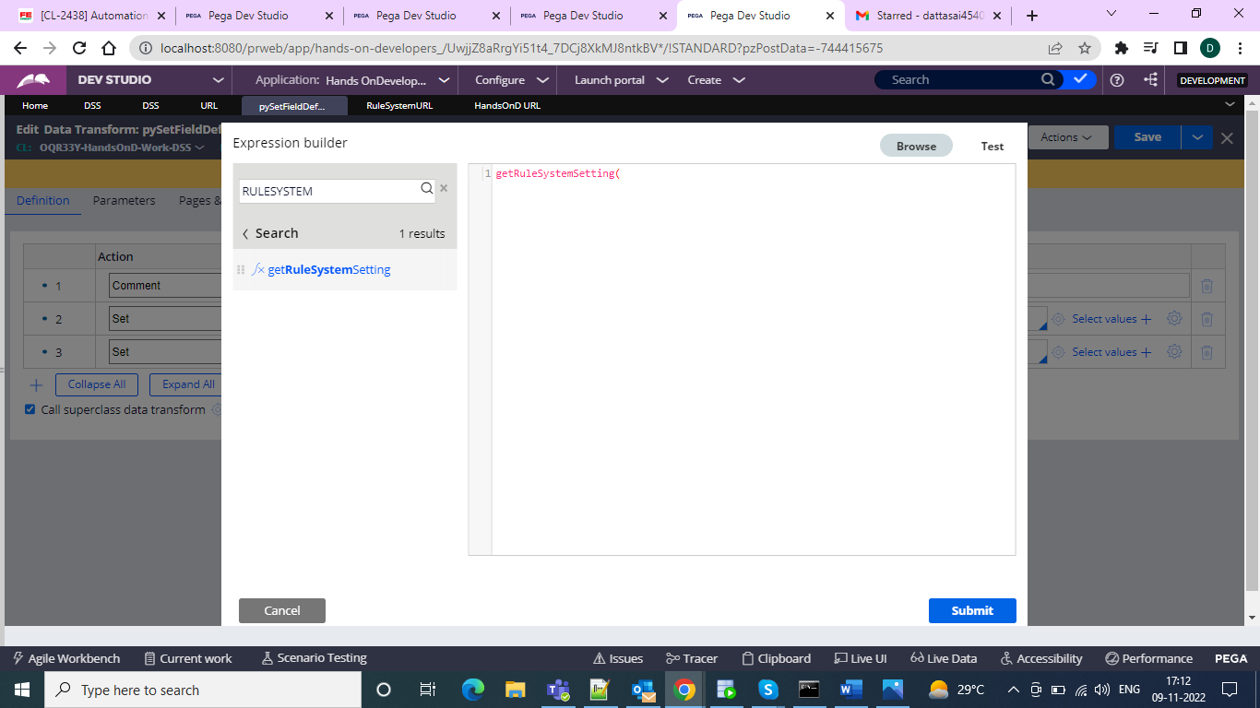

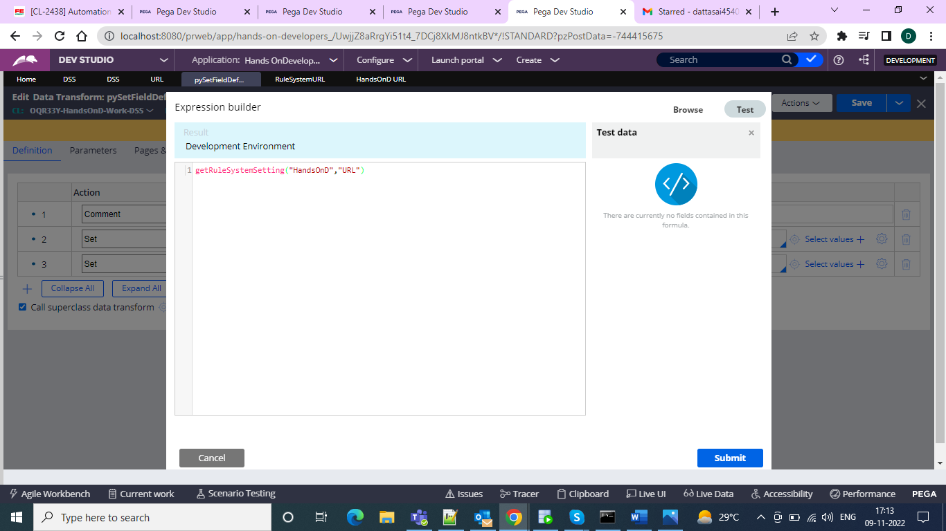

And the result is

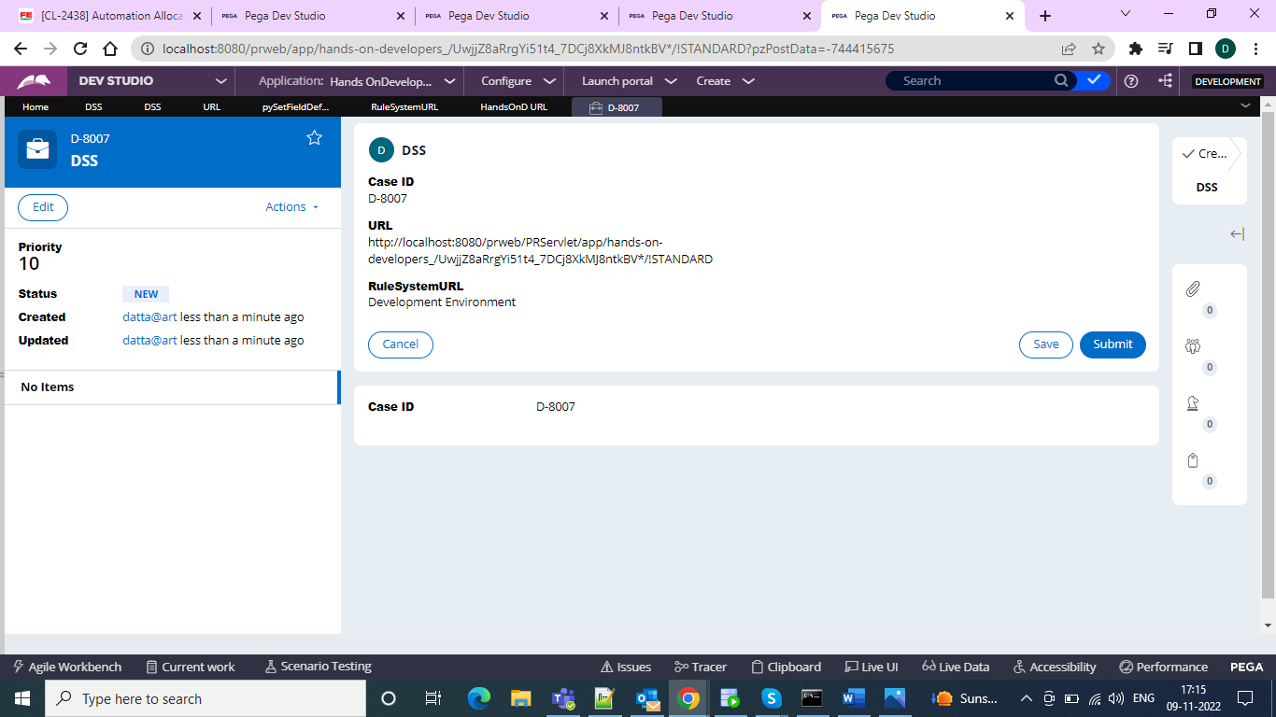

And in the next thing we can have the Rule system setting s what we declare in application settings same is reflected.

We can see the application settings environment in the clipboard also

Under the system pages under pxProcess we have the pzProductionLevel

Since mine is Dev environment we can see as 2

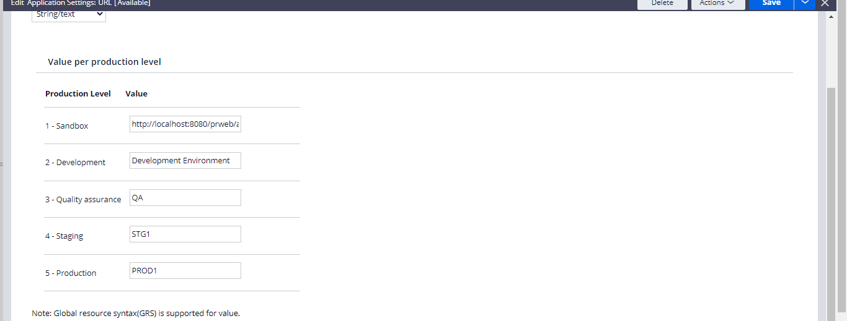

In the clipboard

